Housing Bubble Inflating, RBA Needs to Curb Demand

Christopher’s Housing Boom and Bust Report

THURSDAY 3rd November 2016

The Reserve Bank of Australia will need the Australian Prudential Regulation Authority to reign in home lending once again, or lift interest rates, or do both to avert a dangerous housing bubble, says housing expert Louis Christopher in his newly released Christopher’s Housing Boom and Bust Report 2017.

Louis Christopher, the Managing Director of SQM Research, said: “The housing market is currently at its second most overvalued point on record and now, given a combination of factors including loose monetary policy, strong population growth and booming local economies, prices in Sydney and Melbourne will be rising from this very lofty valuation point.”

SQM Research forecasts an acceleration of dwelling price rises in Sydney and Melbourne with Sydney dwelling prices forecasted to rise 11% to 16% for the 2017 calendar year, while Melbourne is forecasted to rise by 10% to 15%. The capital city average forecast is for dwelling prices to rise 6% to 10%.

The forecasts assume a stable interest rate environment, a stable exchange rate and no further home lending restrictions by APRA. If lending rates are cut again by the RBA, Sydney and Melbourne prices could rise by up to 18% for the year as forecasted by SQM’s “Scenario 2 outlook”.

“The end of 2017 will see both Sydney and Melbourne markets dangerously overvalued and paving the way for a possible correction in 2018,” Christopher said.

“The authorities need to take action sooner rather than later. Failure to do so will result in double digit national housing price growth in 2017 driven by out-of-control Sydney and Melbourne housing markets.

“The problem this time round is tapping on APRA’s shoulders once again could be a little more complicated as it will need to involve restricting owner occupied credit growth – something which the banks will be more reluctant to do. And given the recent announcement of the 7% interest rate servicing test, APRA may well feel reluctant to take further action.”
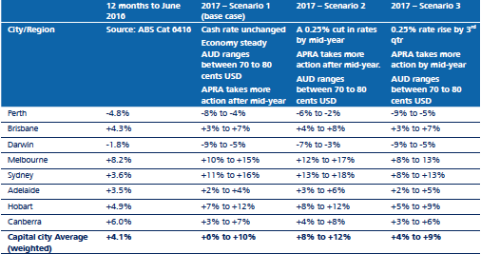
Source: Christopher’s Housing Boom and Bust Report 2017
Elsewhere in the nation, the housing market is expected to be mixed, with Perth and Darwin prices expected to fall again. However, it is likely 2017 will be the last year of price falls generated by the mining downturn for these cities.

Behind Sydney and Melbourne, Hobart is expected to be the next fastest growing city, with Hobart dwelling prices forecasted to rise 7% to 12%.

Brisbane is forecasted to rise 3% to 7% with the market been held back by an existing oversupply situation of dwellings which is covered in detail in the report. Please also see SQM’s separate media release on dwelling oversupply for 2017 and 2018.

Meanwhile, Canberra has now entered into a slow housing recovery with prices also expected to rise 3% to 7%. Adelaide is expected to rise a modest 2% to 4% for next year.

Christopher’s Housing Boom and Bust Report this year also has a full breakdown of every postcode in the country covering current market statistics and its inaugural postcode investor ratings. The full report can be found on www.sqmresearch.com.au for $59.95.

About SQM Research
SQM Research Pty Ltd is a respected Australian investment research house, specialising in providing ratings and data across all major asset classes.

Media Inquiries
For further information please contact Louis Christopher:
Louis@sqmresearch.com.au

Kimberley Phillis
kimberley@sqmresearch.com.au
612 9220 4603
-ENDS-

