**January Vacancies Fall As Year Begins**

**SQM Research Vacancy Rates Media Release**

**Tuesday 17th February 2015**

**For Immediate Release**

Figures released by SQM Research this week have revealed the number of residential vacancies fell nationally in January 2015, with a vacancy rate of 2.3% posted nationally based on 69,847 vacancies, down from 2.6% in December when vacancies hit 77,000. Falls were recorded in all capitals cities, following an influx of renters securing accommodation to start the New Year.

Over the month, vacancy rates fell the most in the big population centres of Melbourne, Brisbane, Canberra and Sydney as workers and students sought accommodation after vacating premises during the summer break.



Over the year to January 31, Hobart recorded the biggest yearly decline in its vacancy rate, reflecting a stronger economy which has been boosted by tourism and a lower Australian dollar. Modest falls were also posted in Canberra and Melbourne.

In contrast, the vacancy rate has jumped in Darwin and Perth from January 2014, reflecting the impact of the commodities downturn on rental demand in those cities. Managing Director of SQM Research, Louis Christopher, said vacancy rates in Darwin and Perth would likely continue rising in 2015 as the mining sector continued to contract given falling commodity prices.

“The mining downturn has caused a big contraction in employment in the mining and resource-related sectors, particularly in temporary/contract jobs, and that will likely continue to push up the jobless rate in Perth and Darwin. So we expect to see even weaker demand for rental accommodation and a continued rise in vacancy rates in those cities, which would push rents down to more affordable levels after they jumped during the commodities boom.”

As can be seen from the table below, SQM Research data reveals asking rents in Perth and Darwin have dropped significantly. Over the year to February 12, asking rents for houses in Darwin fell 11.4% and dropped 3.4% for units, with Perth recording a 7.2% fall in asking rents for houses and a 4.7% decrease for units.

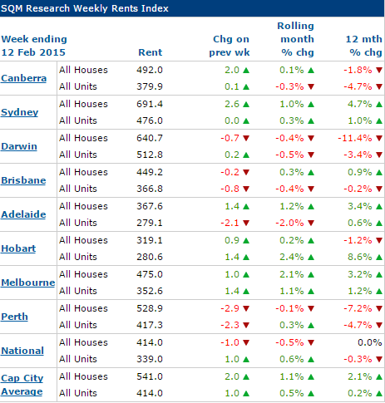

Source: [www.sqmresearch.com.au](http://www.sqmresearch.com.au)

SQM’s calculations of vacancies are based on online rental listings that have been advertised for three weeks or more compared to the total number of established rental properties. SQM considers this to be a superior methodology compared to using a potentially incomplete sample of agency surveys or merely relying on raw online listings advertised.Please go to our [methodology page](http://www.sqmresearch.com.au/graph_vacancy.php?region=nsw::Sydney&type=c&t=1#terms) below for more information on how SQM’s vacancies are compiled.

**Key Points**

* Nationally, vacancies fell during January, recording a vacancy rate of 2.3% and coming to a total of 69,847 vacancies nationally.
* Hobart recorded the tightest vacancy rate at 1.3%, down from 1.4% in December, based on 357 vacancies, and down from 1.6% a year earlier.
* Darwin recorded the highest vacancy rate of the capital cities at 3.3% in January 2015 based on a total of 905 vacancies.
* Darwin recorded the highest yearly increases in vacancies, climbing by 1.8 percentage points from a year earlier.
* Perth’s vacancy rate was 2.6% in January 2015, up 0.7 percentage points from a year earlier.
* During January 2015, the vacancy rate fell the most in Melbourne, down 0.5 percentage points from December, followed by falls of 0.3 percentage points for Brisbane, Canberra and Sydney.

www.sqmresearch.com.au

**About SQM Research**

SQM Research is an independent property research house which specialises in providing accurate property related research and data to financial institutions, property professional, real estate investors and the media. It is owned and operated by one of the country’s leading property analysts, Louis Christopher.

For six years Louis was Head of Research and then General Manager of Australian Property Monitors before leaving the firm to launch SQM Research.

For further information please contact Natalie Keech: [Natalie@sqmresearch.com.au](mailto:Natalie@sqmresearch.com.au)

**-ENDS-**