Vacancy Rates Rise in November

SQM Research Vacancy Rates and Asking Rents Media Release
Tuesday 13th December 2016
For Immediate Release
Figures released by SQM Research this week reveal that the number of national residential vacancies rose in November, with rises in most cities and 78,629 rental homes available, giving a national vacancy rate of 2.5%, up from 2.3% in October.
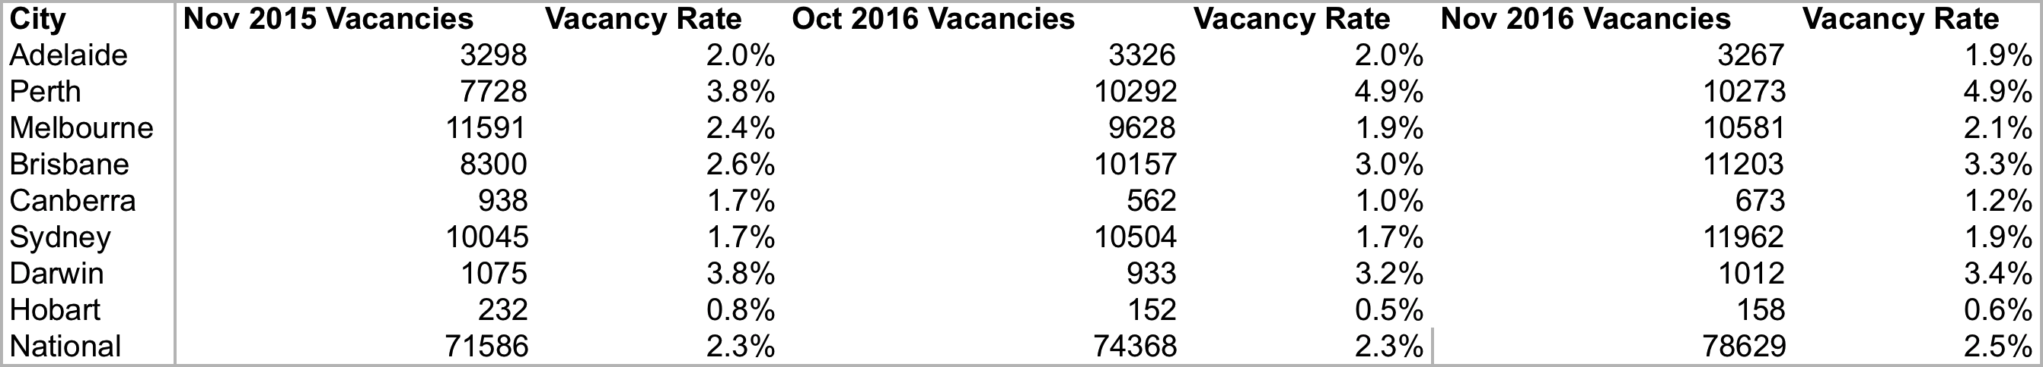
The vacancy rate rose the most in Brisbane, up to 3.3% from 3.0% in October 2016, as the number of rental homes available jumped. Sydney and Melbourne also recorded vacancy rate rises to 1.9% and 2.1%, respectively, up slightly over the month. Year-on-year results reveal the national vacancy rate is slightly higher.
Hobart reported the lowest vacancy rate of just 0.6%, though it was up slightly from the previous month while the vacancy rate dropped in Adelaide to 1.9%, bucking the national trend.
Asking rents
With vacancy rates up, rents eased slightly in Sydney over the month to December 12, where asking rents for houses sat at $736 a week and $509 for units. Asking house rents rose in Canberra by 2.7% to $540 a week and $412 for units with a vacancy rate of 1.2%.
Managing Director of SQM Research, Louis Christopher, said: "The national vacancy rate has risen, which is not uncommon in November as the year winds up. This has taken pressure off rents in Sydney, though it is still the nation’s most expensive city for tenants. Asking rents too have slipped back in Perth with the continued effects of the mining downturn.
“In Brisbane, the vacancy rate has continued to rise in November following a rise in October, and with more unit supply coming onto the market in 2017, the vacancy rate could move even higher in 2017, taking further pressure off rents,” said Christopher.
Hobart continues to offer the most affordable house rents at $352 for a house and $304 for a unit, with Adelaide the next most affordable city with rents for houses at $366 and $288 for units a week.
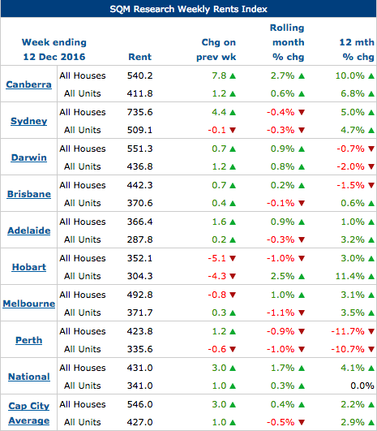
Source: www.sqmresearch.com.au
Reflecting its high vacancy rate, Perth has recorded falls in asking rents for houses over the year to December 12 of 11.7%. Rents, however, have steadied in Darwin, down just 0.7% over the year for houses, with a vacancy rate of 3.4%.
SQM’s calculations of vacancies are based on online rental listings that have been advertised for three weeks or more compared to the total number of established rental properties. SQM considers this to be a superior methodology compared to using a potentially incomplete sample of agency surveys or merely relying on raw online listings advertised. Please go to our methodology page below for more information on how SQM’s vacancies are compiled.
About SQM Research
SQM Research Pty Ltd is a respected Australian investment research house, specialising in providing ratings and data across all major asset classes.
For further information please contact Louis Christopher:
Louis@sqmresearch.com.au
-ENDS-

